Comparative study of countries

1. Create a geographic map showing the countries' fields. Color the map based on the income column from the secondary dataset
   1. Include income group filter in the dashboard

The first step is to load the data. For that go to data source and then click on add. Once data file is uploaded drag the required table on the empty canvas. Same steps can be followed to more than one data source

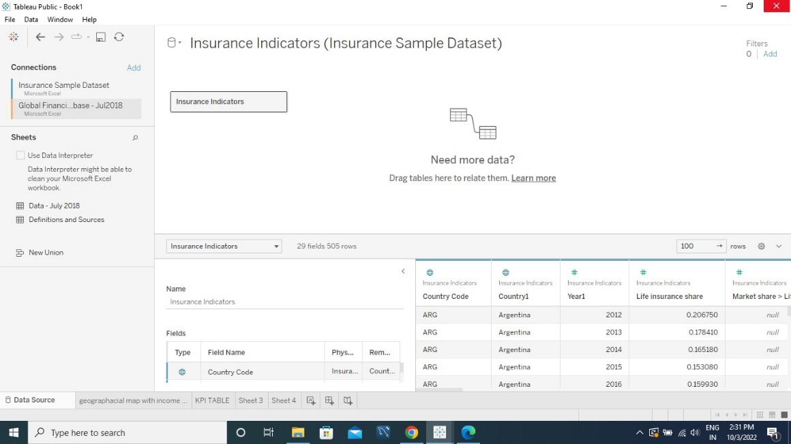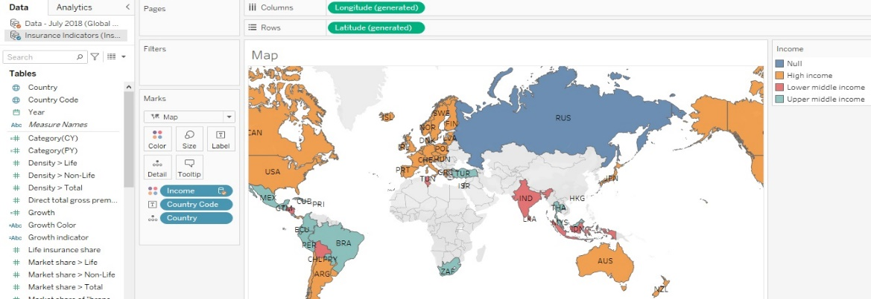f

1. Include a webpage to show data from the world bank webpage driven by an URL action from a geography graph
   1. The country names in the map will act as the trigger

<https://en.wikipedia.org/wiki/Country>

We have used web page object of dashboard along with “go to url” action present in dashboard for dynamic and interactive dashboard. Actions are interactive element in tableau. They are another way to make dashboard interactive.

1. Create a KPI Table to show the comparison between the selected period and the period prior to the selected one
   1. Create two parameters for Year Selection and Category Selection

For creating parameter click on drop don arrow next to search

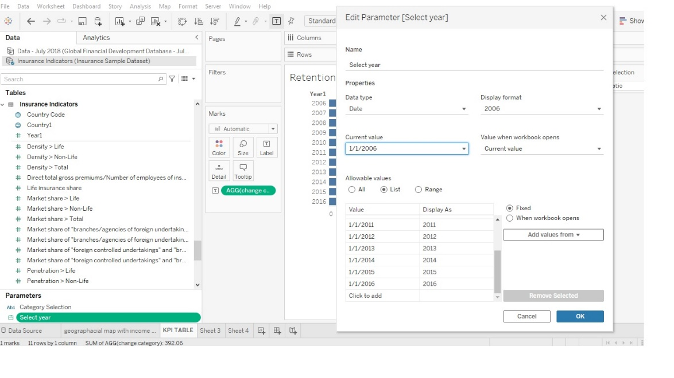

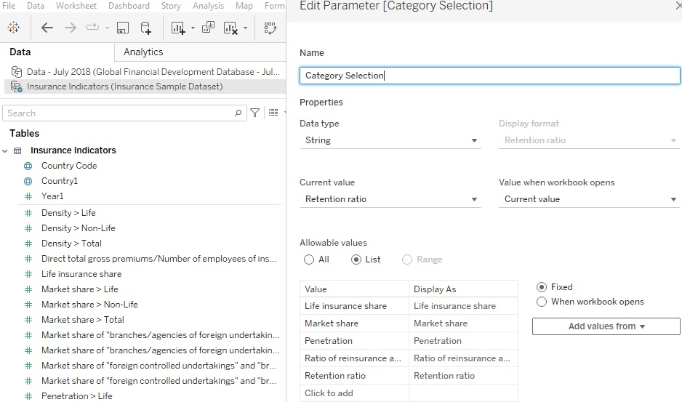

* 1. Category parameter includes life insurance share, market share, penetration, ratio of reinsurance accepted, and retention ratio

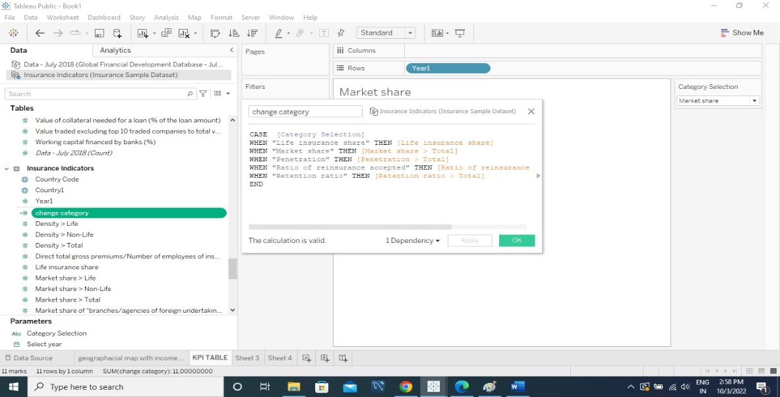

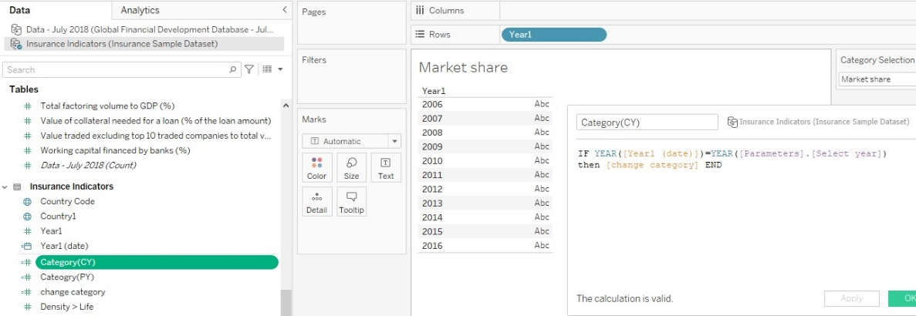

* 1. Create a calculated field to calculate the Growth %

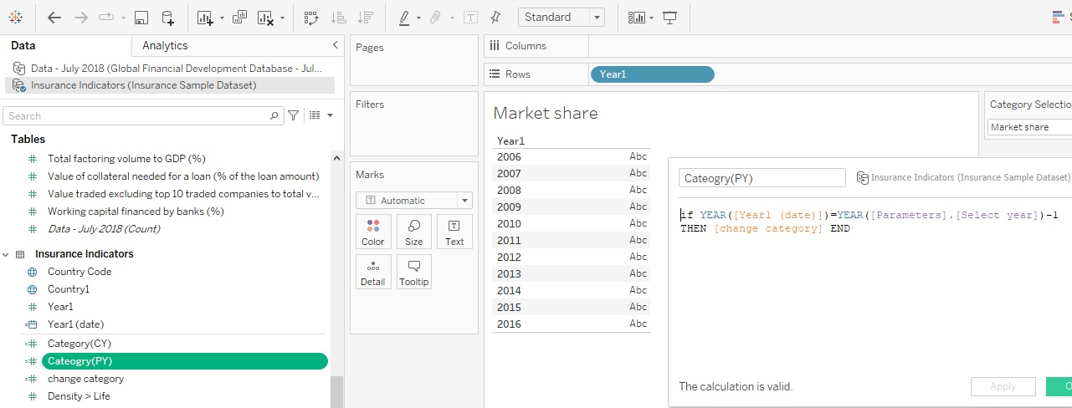

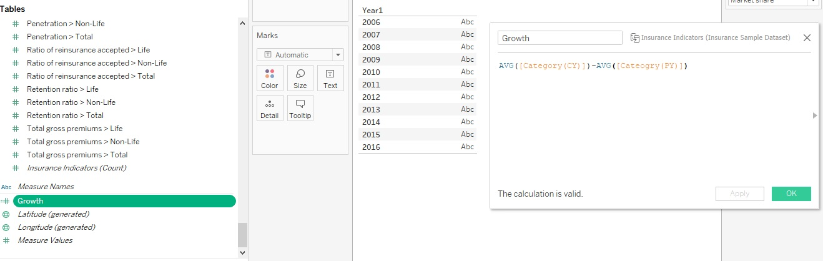

* 1. Create a table to show these values

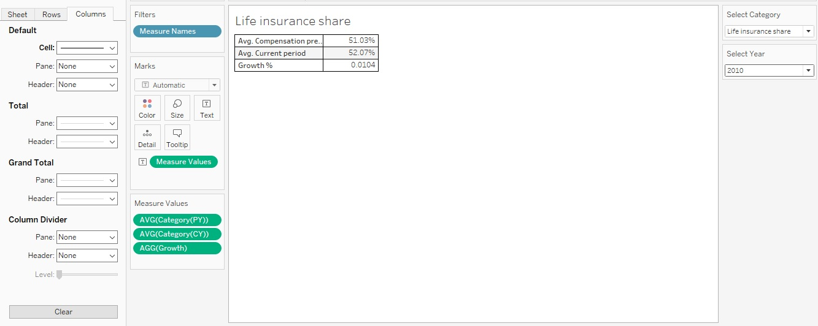

1. Create Growth Indicator Shapes based on the Growth %
   1. Growth indicator displays Negative, No Change, and Positive as values and corresponding shapes against it

For adding shapes in calculated fields press Alt +; It will open special character window that are supported by tableau

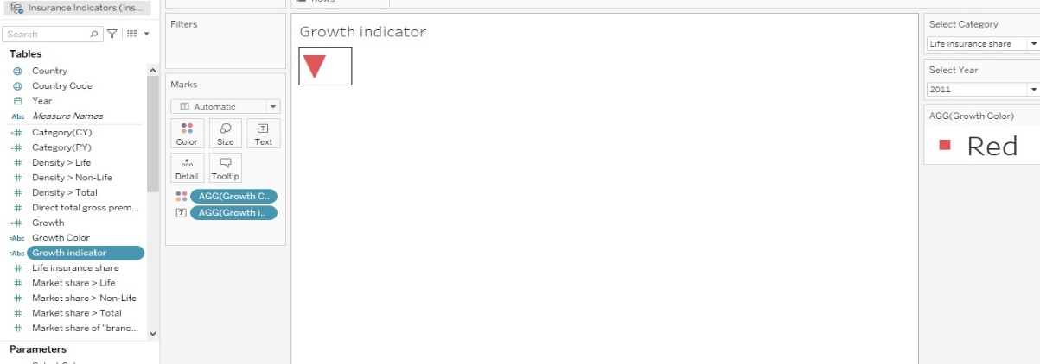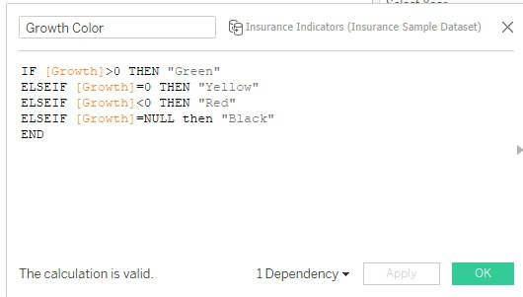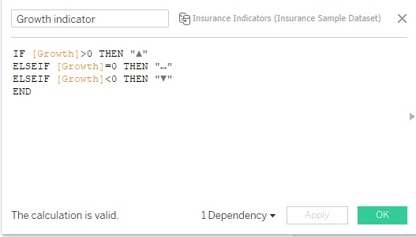

1. Create a trend line to show the selected category values
   1. The line shows an arrow or triangle at the last mark

To create trendline we have used advance visual effects in tableau. The steps are as follows:

Drag category selection to rows and year to columns. After that drag year to pages tab on tableau worksheet. As soon as we will drag yea to pages tab show history and trails section will appear on right hand side panel.

The line to show an arrow at the end go to shapes and select triangle image.

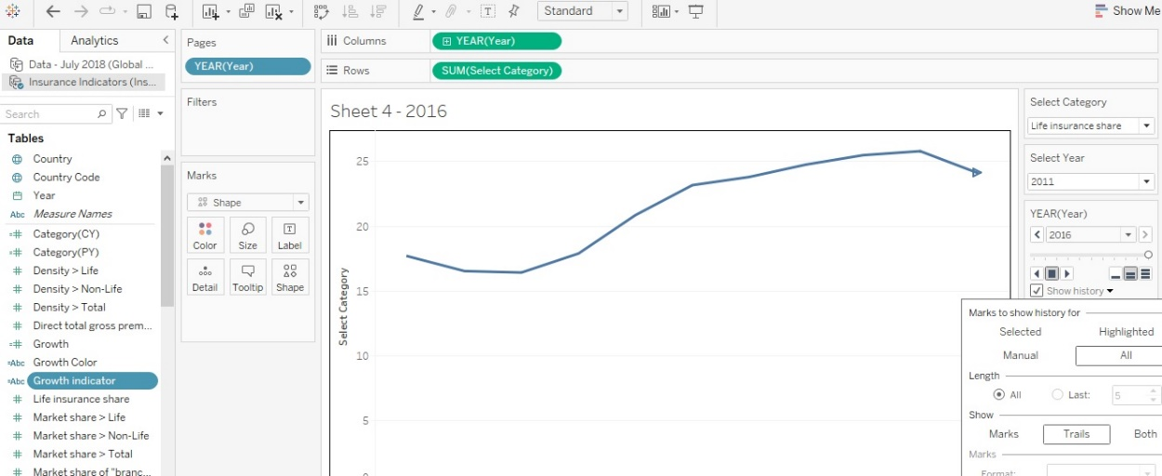

1. Create a dashboard filter for income group to be applied for all charts with the filter action enabled in the map as well

